**CS673S16 Software Engineering**

**Team X - Project Name**

**Tests Report**



|  |  |  |  |
| --- | --- | --- | --- |
| Team Member | Role(s) | Signature | Date |
| Xiang Chen | Configuration Leader;  Integration Environment Leader | *Xiang Chen* | 10/24/2017 |
| Yansen Liu | Design leader | *Yansen Liu* | 10/26/2017 |
|  |  |  |  |
| Weicheng Yu | Backup Team Leader; Security Leader; | *Weicheng Yu* | 10/26/2017 |
| Lu Min | QA Leader | *Lu Min* | 10/26/2017 |
|  |  |  |  |
|  |  |  |  |
|  |  |  |  |

**Revision history**

|  |  |  |  |
| --- | --- | --- | --- |
| **Version** | **Author** | **Date** | **Change** |
| **alpha** | **Team 3** | **10/30/2017** | **Complete main features** |
|  |  |  |  |

Introduction

Test Summary

Tests Reports

Testing Metrics

References

Glossary

# Introduction (Xiang)

In this section, give a summary of this tests report document.

In order to detect fault/error/defects and provoke failures in a planned way, we followed the test driven development for our project. We conduct unit test, module test, integration test, system test and acceptant test on our project and try to solve the bugs / defects that comes from this process. This report is aim to describe the whole test process for different components with details and explanation.

# Test Summary (Xiang)

In this section, you will summarize what was tested and what happened, based on each test type.

* + Unit Tests

**Test Scope**: Individual component (class or subsystem)

**Purpose**: Confirm that the component or subsystem is correctly coded and carries out the intended functionality

**Example and Practice**:

1. Each php action function like create_story(), delete_story(), sort_by_hand()
2. Each php condition function like isMobile(), isPassDue(), hasTag()
3. Each javascript function like pop_windows(), regular_check()
4. Each JQuery function like hide(), show(), toggle()

**Result**: most of unit test has been passed successfully, few unit test has also been passed after some code change and modification.

* + System Tests

**Test Scope**: The entire system (on test bed)

**Purpose**: Determine if the system meets the requirements (functional and nonfunctional)

**Example and Practice**:

1. Create single story , edit it and delete it using dummy data
2. Sort different story based on their due day
3. Create single sprint , edit it and delete it using dummy data
4. Merge all story together and sort them by hand

**Result**:In some cases, the input with special characters can not be accepted. Then we modified the regular expression and also add pre-check function to the system. After that, the problem has been solved. All system test passed successfully.

* + Acceptance Tests

**Test Scope**: The entire system delivered (on final platform)

**Purpose**: Demonstrate that the system meets the requirements and is ready to use

**Example and Practice**:

1. Given a Project created and its subsidiary user story created, when I want to change specific user story description and input the new requirements or replace current description to an updated one into input box, then a clickable edit button displays , allowing me to change user story description. After clicking edit button, I can add, replace, delete descriptions.
2. Given a new user story was created, when a user added a description to the user story and clicked save button, then this user story would successfully have detailed description.
3. Given a project with some finished requirement, when the product owner want to delete some finished requirement and click on the delete button right on each finished requirement history, then the requirement history will be deleted and cannot restore.

**Result**: We passed most of the acceptance tests and meet their requirements. However, some features in the acceptance tests has not been implemented yet. Few features needs to be improved in the future. We plan to make some code change in the final iteration to pass all the acceptance tests.

# Tests Reports (Lu, Yuhao(not correct), Dawei, Yansen-> two test cases each person)

Example: <https://www.guru99.com/test-case.html>

(check the video and tables )

In this section, you will give a detailed description of each test case performed and the result. You shall list what are existing tests developed in the previous semester and what are new tests developed currently.

For each test case, you can use the following template (or something based on the following template)

* Test case ID, name
* New or old:
* Test items: (what do you test )
* Test priority (high/medium/low)
* Dependencies (to other test case/requirement if any):
* Preconditions: (if any)
* input data:
* Test steps:
* Postconditions:
* Expected output:
* Actual output:
* Pass or Fail:
* Bug id/link: (this should link to your github issue id)
* Additional notes:

(You can use an additional table or document for this section)

[Additional table link](https://docs.google.com/spreadsheets/d/1CGYv17k1YQjrvvOj_J151QLHhNvMrDJkOoC_8Az-tYg/edit#gid=0)

# Testing Metrics (Lu, Weicheng,Yuhao(missing); at least two table, two graph, with explanation)

// Instructions from professor

Table Example: <https://www.slideshare.net/deepikashanti/13-software-metrics>

(especially from page 16 to end)

Graph Example: <https://www.qasymphony.com/blog/64-test-metrics/>

In this section, you shall report the any metrics used for the evaluation, e.g. coverage, defects rate, etc.

// Actual stuff

Table 1. Size Oriented Metrics

|  |  |  |  |  |  |  |
| --- | --- | --- | --- | --- | --- | --- |
| Sprint # | Line of Code (lines) | Total Effort (man hour) | Document Produced  (pages) | Errors Found in Test (count) | Defects found in sprint  (count) | User Story Implemented  (count) |
| Sprint0 | 10 | 159 | 24 | 0 | 0 | 0 |
| Sprint1 | 1458 | 166 | 72 | 10 | 3 | 3 |
| Sprint2 |  |  |  |  |  |  |
| Sprint3 |  |  |  |  |  |  |

Details on Table 1:

In this section, details on how each column is calculated will be explained.

Line of Code: Total lines of code on github before the first presentation. Sprint 0 also has some lines on github because each teammate try to commit on readme file.

Total Effort in Man Hour: Total actual hours on weekly report excel file for each sprint.

Document Produced: Total pages of documentation on google drive for each sprint.

Errors found in test cycle: Known bugs in each sprint that do not have time to resolve.

Defects found in sprint: Issues on github each sprint.

User Story Implemented: User Stories on pivotaltracker that were implemented in each sprint.

Table 2. Function Oriented Metrics

|  |  |  |  |  |  |  |
| --- | --- | --- | --- | --- | --- | --- |
| Measurement Parameter | count |  | Simple |  |  |  |
| Number of User Story |  |  |  |  |  |  |
| Number of Sprint |  |  |  |  |  |  |
| Number of description |  |  |  |  |  |  |
|  |  |  |  |  |  |  |

*(still need to add some explanation of the graphs)*

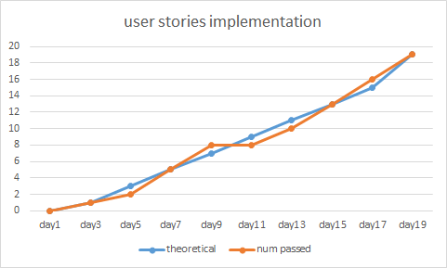

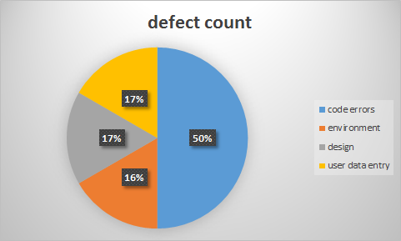

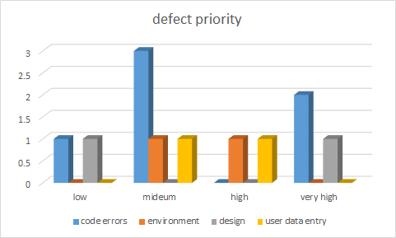

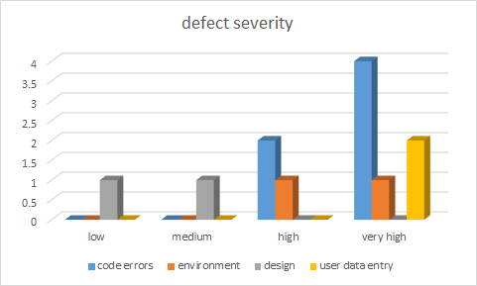

# References ( All)

# Glossary

Presentation : <https://docs.google.com/a/bu.edu/presentation/d/1OncXtilBObhzWB54klBlGucz1yeabmzAWt1fTXEAkRA/edit?usp=sharing>